Escuela Industrial Superior de Valparaíso

Departamento de Inglés
Priorización Curricular
WORKSHEET 6 Rights & Responsibilities
4th Level

Name: _________________________________________Class: ______________________

Objetivo(s) Fundamentale(s) | Indicador(es) de evaluación
OF2. Comprender globalmente distintos tipos de textos orales, auténticos, de fuentes y temas variadas; procesar, asimilar y reaccionar ante la información reciba de acuerdo a sus propósitos e intereses. | Identificar la o las ideas clave que apoyan la idea principal.  Reconocen palabras de vocabulario, expresiones y frases hechas relacionadas con los derechos y deberes de la juventud y las usan al expresarse sobre el tema de la unidad.  Registran información específica, como nombres, datos y cifras.  Integran la expresión escrita

- Match the picture of the human right with the corresponding name.
A | 1)_____ Freedom of expression
B | 2)_____ The right to education
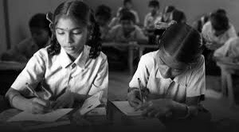 C | 3) ______ Freedom of thought
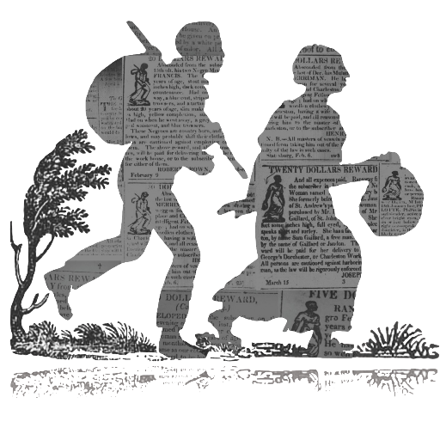 D | 4)_______ Freedom to move

2. Watch the following video about Human Rights:
“What are human rights?” (3:14) https://www.youtube.com/watch?v=8efAdRohMZA
*TIPS (consejos) for watching the video: Watch the video more than once (mas de una vez). You can slow down (ralentizar) the audio of the video. Look up (busca) new words in the dictionary.
Vocabulary in the video:
Take for granted – darlo por sentado, Instinctively expect – esperar instintivamente, Deserve to be treated – merecen ser tratados, In other words – en otras palabras, Lumped together – agrupados, Widely accepted – ampliamente aceptada, Starvation – inanición (o in other words, muriendo de hambre), abolished (verb)/abolish (noun) - abolido

3. Choose true or false for each statement. Correct the false ideas
a) True or False At the beginning of the video, people are not sure what human rights are.
_______________________________________________________________________________
b) True or False Rights are defined as “things to which you are not allowed; freedoms are not guaranteed” _______________________________________________________________________________
c) True or False Human Rights are the rights you have because you are human.
_______________________________________________________________________________
d) True or False The only kind of rights are Human Rights.
_______________________________________________________________________________
e) True or False The Universal Declaration of Human Rights are just words on a page.
_______________________________________________________________________________
4. Now answer these questions about the video.
a) What are the first three (3) human rights mentioned in the video? (1:01)
_________________________________________________________________________________________________________
b) How many human rights exist? (1:54)
_________________________________________________________________________________________________________

Language Use
New connectors: Even though: Aunque (real situations) Even if: Incluso si (unreal or hypothetical situations. As long as: siempre y cuando (condition)
As soon as: Tan pronto como (an events happens immediately after the other)
- Check examples in eiv_english12

5. Fill in the blank with the correct connector found in the box below.
Even though – Even if – As long as – As soon as – Even if

Example: EVEN IF you are young, you should still know your human rights.
a) _________________ slavery was abolished a long time ago, there are still 27 million people enslaved today.
b) You have the right to speak your mind, ______________________ you respect others.
c) _____________________ you are born, you have human rights.
d) You have human rights in every country, ______________________ you are not a citizen of that country.

5. Open-ended question:
a) Do you believe human rights are respected in Chile? Yes? No? Why? Explain your answer. Write at least (por lo menos) 2 sentences.
(Example: I believe that human rights are… in Chile because …)
____________________________________________________________________________________________________________________________________________________________________________________________________________________________________________________________________________________________________________________________________
When you finish this worksheet please send it to your English teachers to receive feedback.
Emails:
Mrs Mónica Martínez: mony1quirqui@gmail.com
Ms Monserrat Martínez: monzimfarina@gmail.com (4°E)

